**BPM Production Support Tasks**

**Tasks**

1. Moving Token
2. Deleting Token
3. Current State
4. Retrieves exposed processes
5. Start Service
6. Resume Service
7. Set Data (Task)
8. Get Data (Task)
9. Exposed Services
10. Task Details
11. Assign Task to User
12. Assign Task to Group
13. Create User
14. Creating Group , add User to the Group Add the Group to the Other Group
15. Process Monitor
16. Event Manager > Monitor
17. Update EPV
18. Suspend Process
19. Terminate Process
20. Migrate Instances – Impact Analysis
21. Team Binding
22. What is Default Version
23. Update ENVs
24. Download Process App

BPM Consoles:

REST API: <https://hostname:PortNumber/bpmrest-ui>

Process Admin: <https://hostname:PortNumber/ProcessAdmin>

Process Center: <https://hostname:PortNumber/ProcessCenter>

Process Portal: <https://hostname:PortNumber/ProcessPortal>

1) **Task Name**: Moving Token

Scenario: There are 4 roles in Process, Second role submitted the case without filling the form and third actor is unable to fill the form due to read only screen what is the work around for the Scenario?

**Solution:**

Move the Token from second role.

i) Get the Current token ID.

i) Go to Rest API Console.

ii) Go to Business Process Manager REST APIs >> Process API >> Current State.

iii) Enter Instance ID, select execution Tree for parts.

iv) Click on execute call and get the current token.

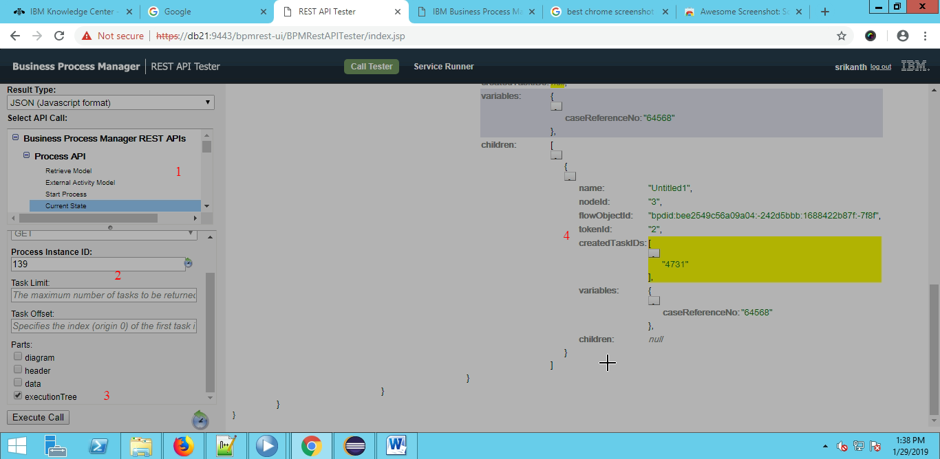

v)Get System ID from BPD by clicking on the Activity(Role1 in the below Image)

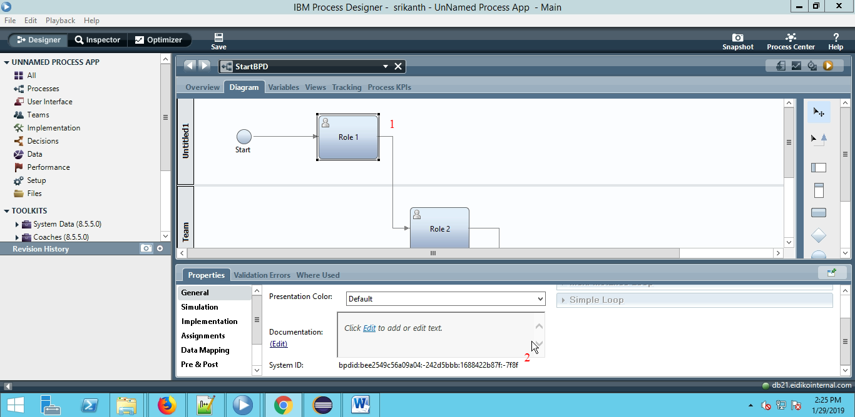

vi) Go to Business Process Manager REST APIs >> Process API >> Move Token

Enter Instance ID, Token ID, System ID as Target.

vii) Click on Execute Call.

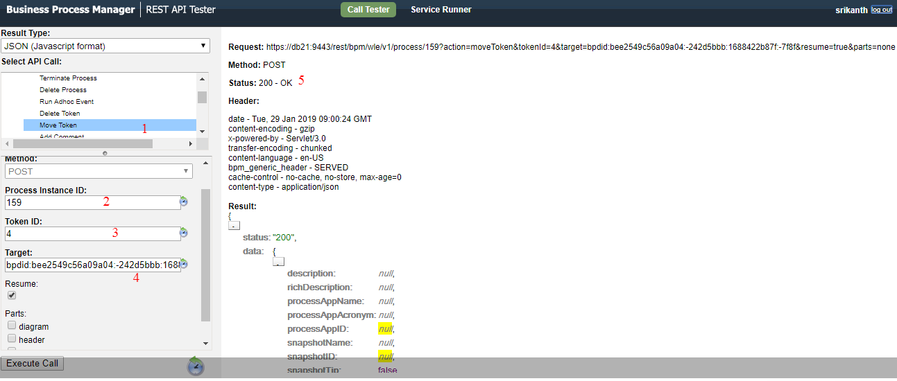

2)**Task Name**: Deleting Token

**Scenario**: Due to Code Bug extra token is waiting at any Human service, and Support Team need to delete token.

**Solution:**

i) Get the token ID(refer task1).

ii) Go to Business Process Manager REST APIs >> Process API >> Delete Token

iii)Enter Instance ID, Token ID click on Execute Call

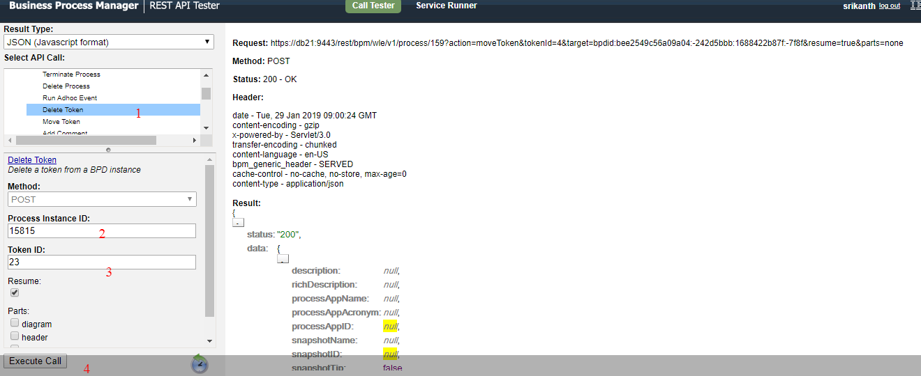

3)**Task Name**: Current State

**Scenario**: How to get the current state of any instance from bpm rest api

**Solution**:

i) Go to Business Process Manager REST APIs >> Process API >>Current State

ii)Enter Instance ID, Select the parts which all data required.

iii)Click on the execute call button

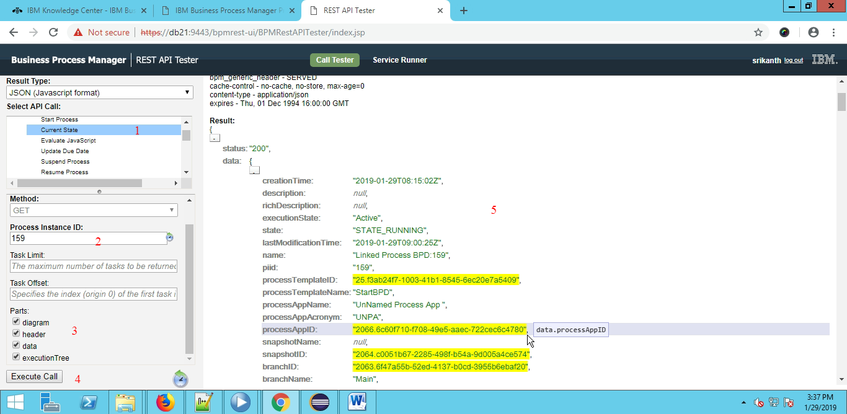

4)Task Name: Exposed processes

Scenario: how do you get the exposed Process using rest api?

Solution:  
i) Go to Business Process Manager REST APIs >> Process API >>Exposed Processes

ii)Click on Execute Call

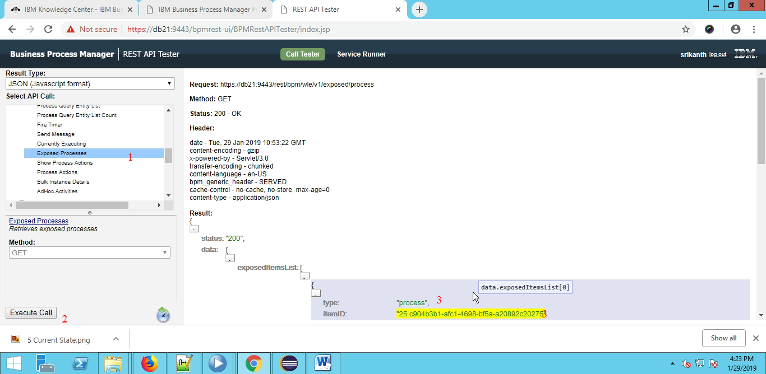

5) Task Name: Start Service

Scenario: How to run any rest services in Production for create instance (example)?

Solution:

i)Go to Business Process Manager REST APIs >> Service API >>Start Service

ii)Start Service ID or Name as “ProcessApp_Acronym@Service_Name”

iii)Enter parameters in JSON format like {‘input’:’165465’}

iv)Click on the Execute Call and get the instance Number in the Output

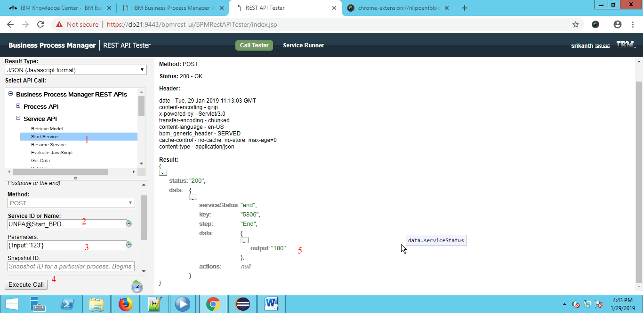

6) Task Name: Resume Service

Scenario: How to resume the suspended Instance ?

Solution:

i)Go to Process Admin> Inspector

ii) Enter the instance ID

iii) Respective instance will be get displayed on screen

iv) Click on the Resume button

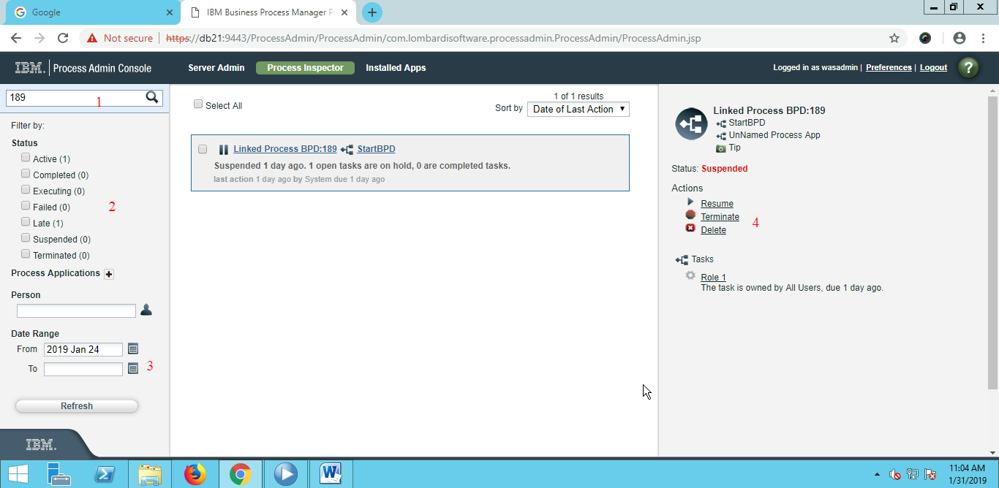

7) Task Name: Set Data

Scenario: How to set Data for a task using Process Admin console

Solution: i)Go to Process Admin> Inspector

ii) Below Terminate button tasks list will be shown.

iii)Click on the tasks and able to see the details of task.

iv) Above task details click on edit data and save to modify the content.



8) Task Name: Exposed Services

Scenario: how to set client side human services url in the production ENVs?

Solution:

i)Go to Business Process Manager REST APIs >> Service API >>Exposed services

ii)click on the execute call and to get the urls and other related attributes.

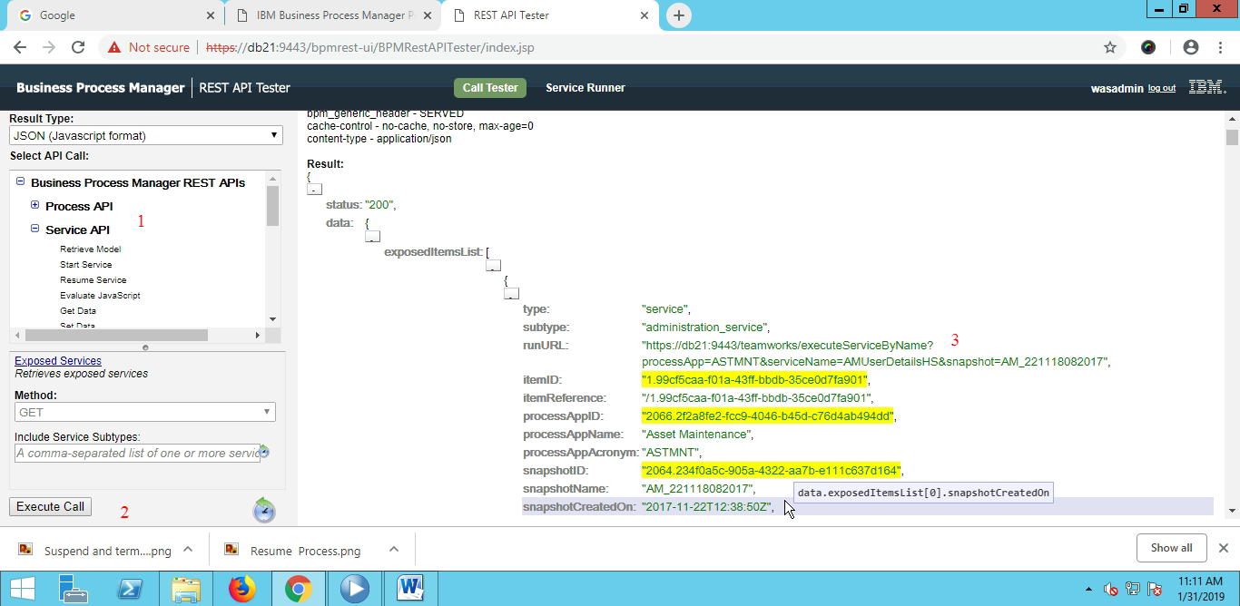

9) Task Name: Task Details

Scenario: How to get the Task Details for a Instance?

Solution:

i)Go to Process Admin> Inspector

ii) Below Terminate button tasks list will be shown.

iii)Click on the tasks and able to see the details of task.



10) Task Name: Assign Task to User

Scenario: How to assign a task to a specific user ?

Solution:

i)Go to Business Process Manager REST APIs >> Service API >>Assign To User

ii) Enter Task id , username

iii) Click on the execute button.

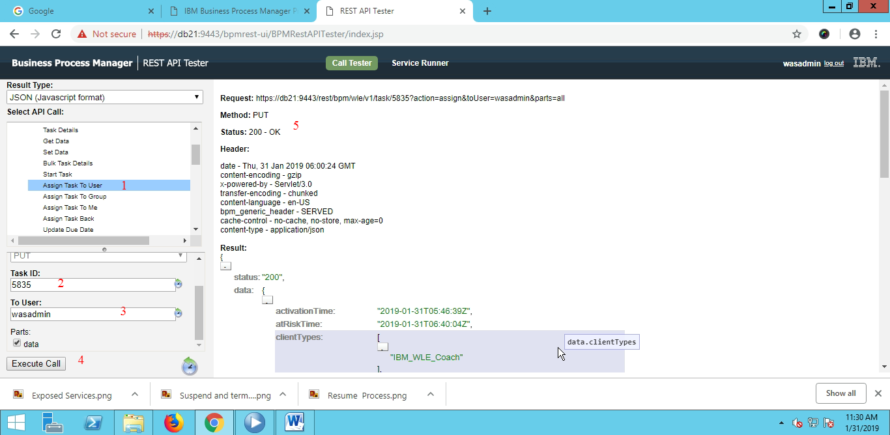

11) Task Name: Assign Task to Group

Scenario: How to assign a task to a group?

Solution:

i)Go to Business Process Manager REST APIs >> Service API >>Assign To Group

ii)Enter task number, group Name.

iii)Click on the execute call button.

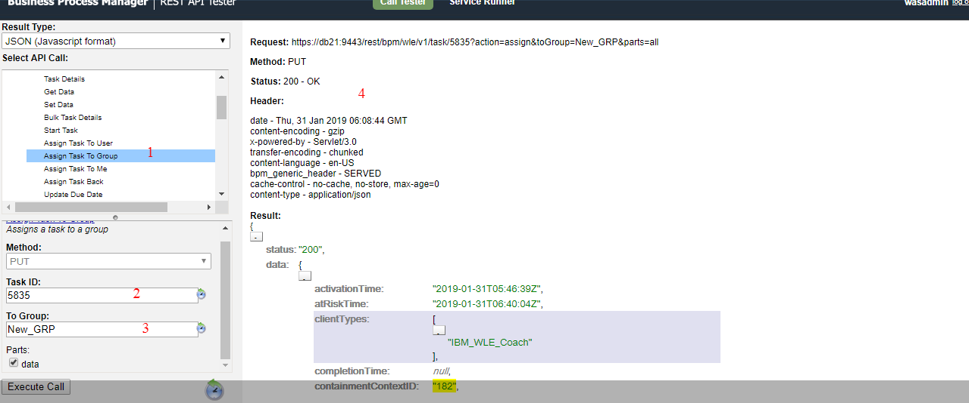

13) Task Name: Create User

Scenario: How to create a user in Process Admin?

Solution:

i)Go to Process Admin Console> User Management>User management

ii) Enter name, Full Name, Passwords click on add button

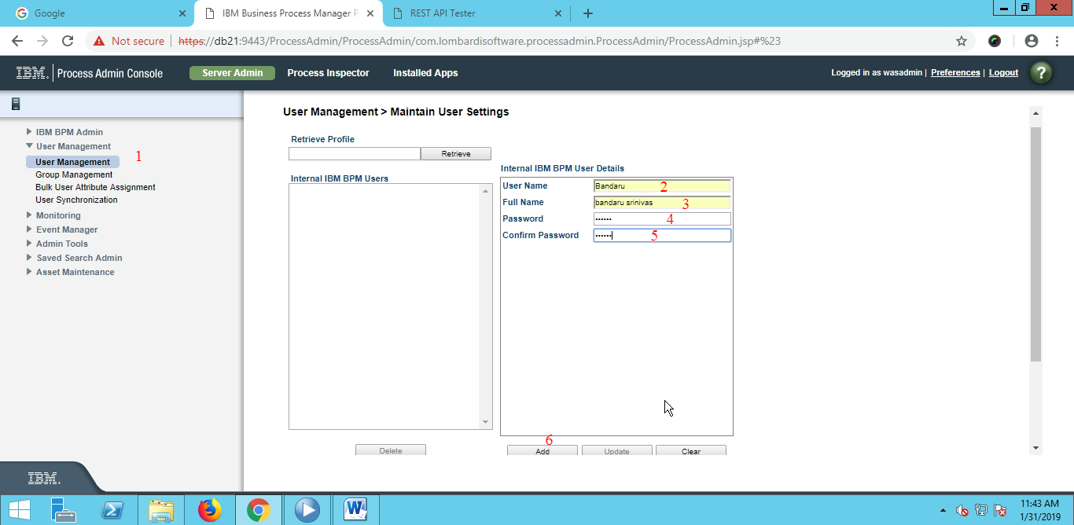

14) Task Name: Creating Group , add User to the Group Add the Group to the Other Group

Scenario: How to Create a Group and how to add a user to that group?

Solution:

i)Go to Process Admin Console> User Management>group management

ii)Click on new group and enter group name and save it.

iii)Search for group name and click on it, click on add users and add the users into group.

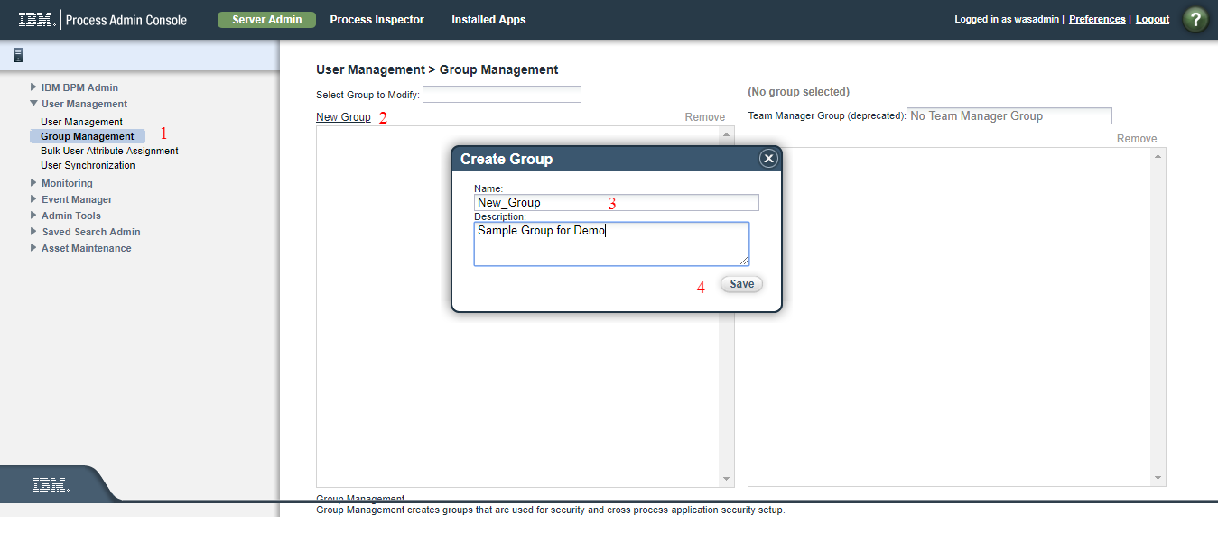

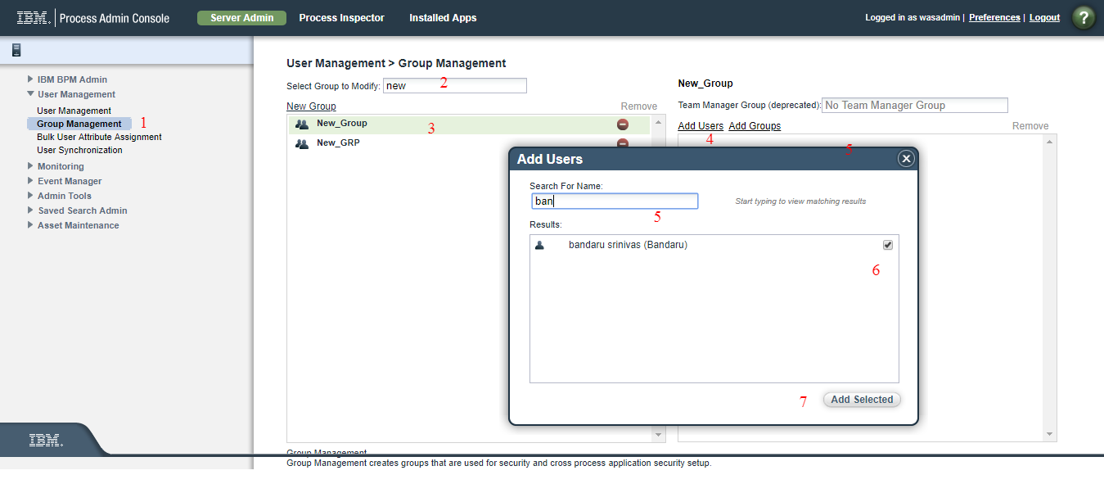

15) Task Name: Process Monitor

Scenario: What will you do as and when the user intimate slowness in Production?

Solution:

1. Go to Process Admin >> Event Manager > Monitor
2. Check any long running process in Service level or Process Level in Monitor
3. If any infinite loops regarding coding, suspend the Instance.

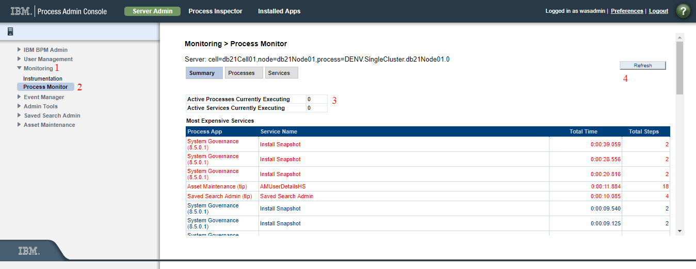

16) Task Name: Event Manager > Monitor

Scenario: How do you check whether the UCAs are getting triggered in the Production or not?

Solution:

i)Go to Process Admin>>Event Monitor>> Monitor

ii)Check whether UCA call in Executing status or in scheduled status.

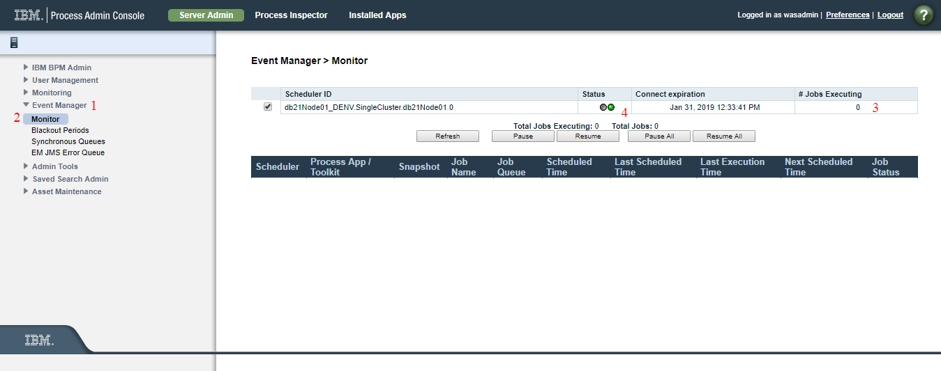

17) Task Name: Update EPV

Scenario: How do you change the EPV in Production?

Solution:

i)Go to Process Admin >> Admin Tools >> Manage EPVs

ii) Select Snapshot, name.

iii) Select a variable from a list and click on new give the value and effective date for EPV should reflect in production click on Ok button.

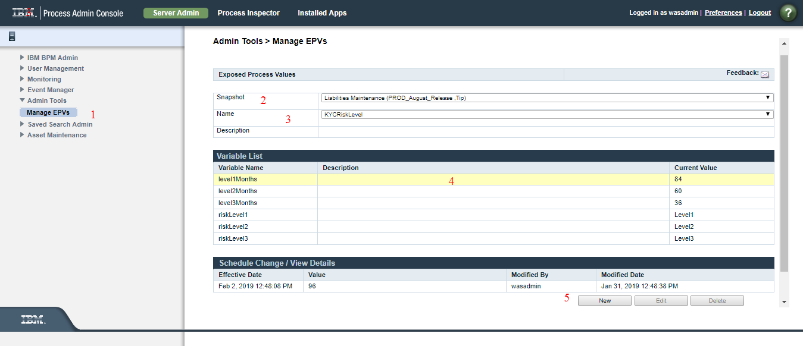

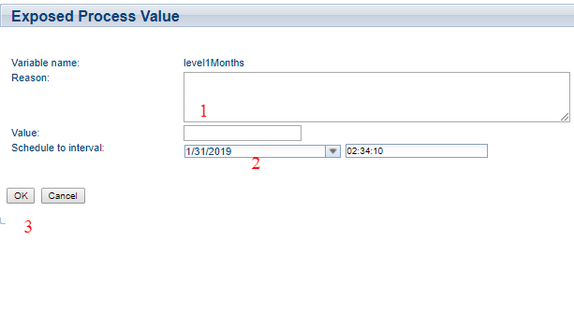

18) Task Name: Suspend Process

Scenario: How to suspend the Process instance?

Solution:

i)Go to Process Admin>>Process Inspector

ii) Enter Instance Number in search field

iii)click on the Process and in the right side click on the suspend Process button.

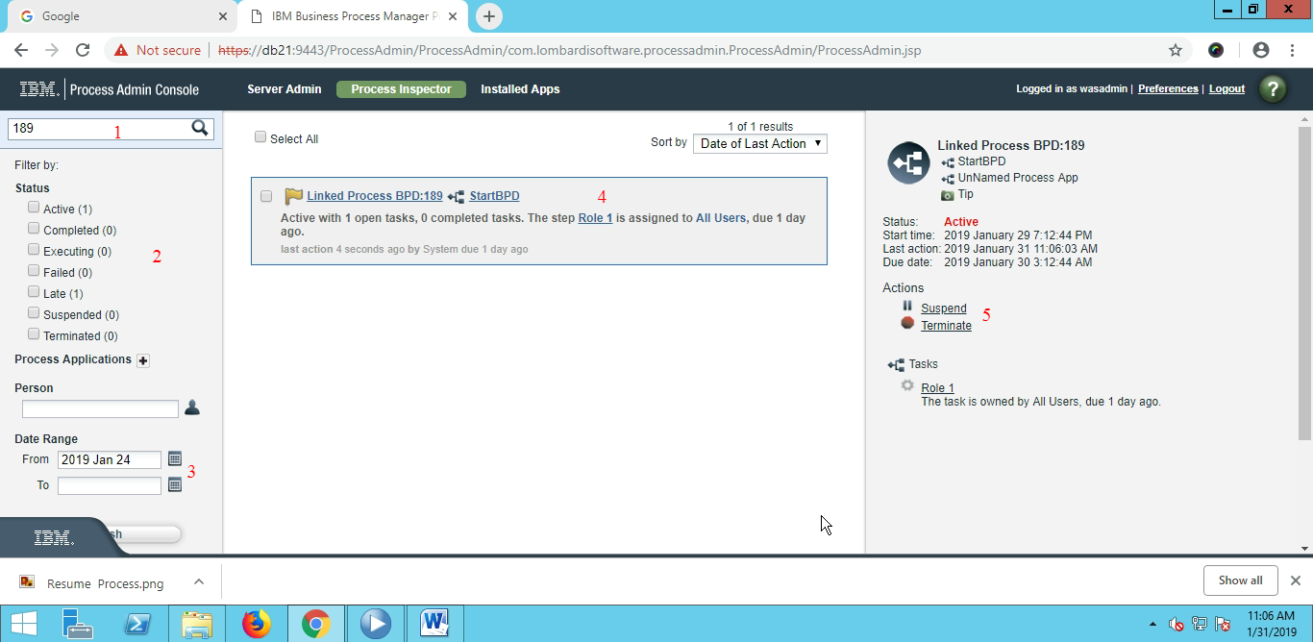

19) Task Name: Terminate Process

Scenario: How to terminate Process instance?

Solution:

)Go to Process Admin>>Process Inspector

ii) Enter Instance Number in search field

iii)click on the Process and in the right side click on the Terminate button.



20) Task Name: Migrate Instances – Impact Analysis

Scenario 1: If a Process application deals with UCAs and new version of the Application need to deploy, then Instance migration is compulsory.

Scenario2: if a new application deploying in production for first time then check below mentioned List.

* Data Source
* Deployment Environment
* Placing of a WSDL file in W.A.S
* ACLs
* Latest updated URLs list for ENVs
* Runnable Scripts (SQL,..)
* Groups and Teams
* Access for Screens

Scenario 3:If a Application deals with client side Human service, respective Screen URLs need to be changed in production

21) Task Name: Team Binding

Scenario: What need to be checked first when Production user raise concerns for Home Screen Access?

Solution: Check for Team binding of a respective service or screen to resolve authorization issues.

22) Task Name: What is Default Version

Scenario: Always there will be only one Active Default Process App can run in Process Server. All the new instances will get created in Active, Default version.

Many Active or Inactive snapshot can be available

23) Task Name: Update ENVs

Scenario: how to update the ENVs in Production?

Solution:

i)Go to Process Admin>> installed Apps

ii)Click on the Process App in “Environment vars” change the Environment Variables accordingly.

24) Task Name: Download Process App

Scenario: How do you download the Process App(without PD)?

Solution: Login to Process Center Console and Download the Process Application directly.